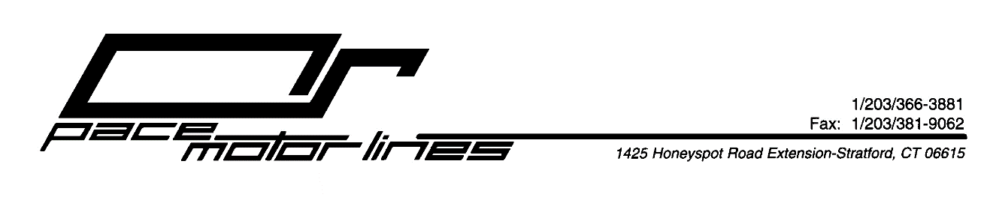
March 20, 2020

To: Our Valued Clients

RE: COVID-19 – Coronavirus – Pace Update
Pace Motor Lines, Inc. has been closely monitoring the Coronavirus COVID-19 updates as they are made available by the CDC, WHO, and government officials.
Pace will remain dedicated to servicing our clients and continue to run fully operational as Transportation and Warehousing services are “essential.”
During this challenging time, we are asking all shippers to confirm with your consignee that they are open for receiving shipments. This will allow all equipment to be available to continue providing the service level our clients are accustomed to, as well as minimizing service disruptions and avoiding any redelivery charges or return of shipments collect to businesses that are closed.
At any time, if you should have questions or concerns regarding our contingency plan, or how we can support you and your business during this time, please feel free to contact your sales representative or email us at sales@pacemotor.com

Patrick W. Pacelli
Vice President

