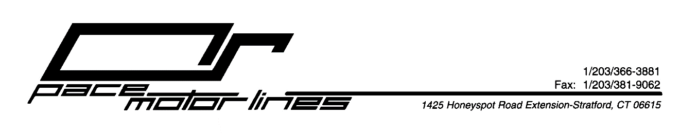
April 20, 2020

RE: COVID-19 – Coronavirus – Pace Update
Effective Monday April 20, 2020 at 8pm for the protection of our employees and clients, we have implemented a policy requiring all employees who are unable to maintain the required safe, six foot distance to wear a face covering.

Thank you,
Pace Motor Lines, Inc. Management

